Horicon Free Public Library
February 2025 Report

Date | Adult | Juvenile | Total | Adult PC  Usage | Juvenile PC Usage | Total PC Usage | Wifi usage | Fines | Copy | Fax | Cash Donations | Totals
2/01/2025 | 04 | -- | 04 | 01 | -- | 01 |  | -- | -- | -- | -- | --
2/03/2025 | 07 | -- | 07 | -- | -- | -- |  | -- | -- | -- | -- | --
2/04/2025 | 10 | -- | 10 | -- | -- | -- |  | -- | -- | -- | -- | --
2/08/2025 | 06 | 01 | 07 | -- | -- | -- |  | -- | -- | -- | -- | --
2/10/2025 | 04 | -- | 04 | -- | -- | -- |  | -- | -- | -- | -- | --
2/11/2025 | 06 | -- | 06 | 01 | -- | 01 |  | .25 | -- | -- | -- | .25
2/13/2025 | 02 | 01 | 03 | -- | -- | -- |  | -- | -- | -- | -- | --
2/15/2025 | 07 | 02 | 09 | -- | -- | -- |  | $30.00 (check) | -- | -- | -- | --
2/18/2025 | 12 | 01 | 13 | -- | -- | -- |  | -- | -- | -- | -- | --
2/20/2025 | 05 | -- | 05 | -- | -- | -- |  | -- | -- | -- | -- | --
2/22/2025 | 07 | 02 | 09 | -- | -- | -- |  | -- | -- | -- | -- | --
2/27/2025 | 16 | -- | 16 | -- | -- | -- |  | -- | -- | -- | -- | --
Totals | 86 | 07 | 93 | 02 | -- | 02 | 104 | .25 | -- | -- | -- | .25

Check Donations | Donator | Deposit Date | Thank you sent
$3,249.25 | Mary and George Zimmerman Foundation | 2/18/2025 | Y

Instances of wifi sessions
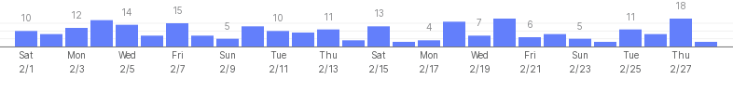

Month | Adult Patrons | J Patrons | Total Patrons | Adult PC  Usage | J PC Usage | Total PC Usage | Wifi | Total fines etc. | Cash Donations
January | 113 | 22 | 135 | 01 | 01 | 02 | 107 | $6.30 | --
February | 86 | 07 | 93 | 02 | -- | 02 | 104 | .25 | --

Petty Cash
Total Remainder:
=$9.14

Donations box: -- Reference Questions: --

New patrons:
Visitors: 01

Notary services utilized: --

Tutoring:
Adult: --
Kids: --

Volunteers:
Adult: 01
Juvenile: --

Dungeons & Dragons Club
Date | Attendance
2/22/2025 | 02

